**Assignment No: - 8**

Deploy a project from a local machine to GitHub and vice versa.

1. Search for GitHub and sign in or log in if already you have an account with your Username or email address and password.

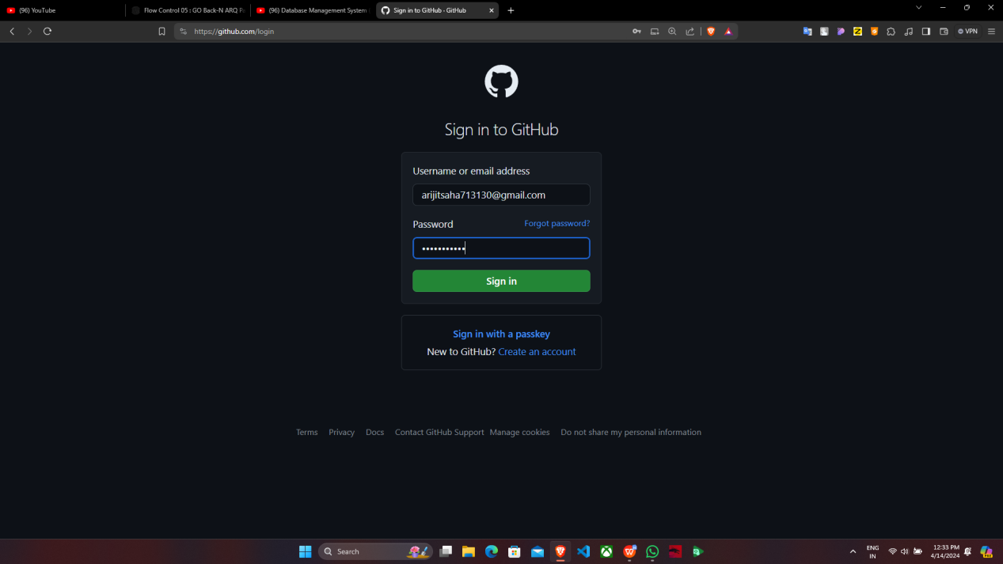

mainakcr72002@gmail.com

1. Now click on “New”.

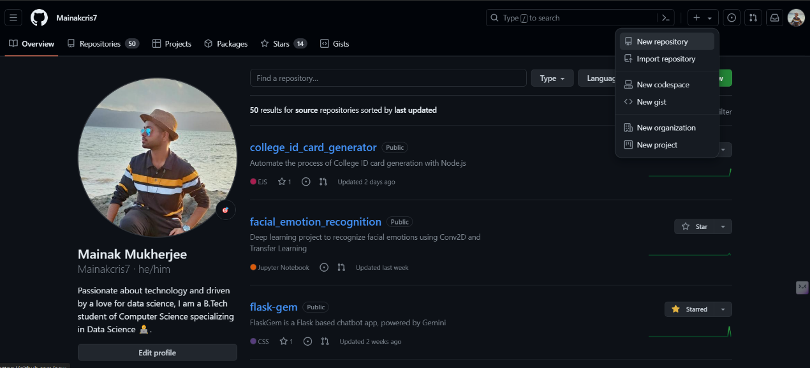

3. Under “Create a new repository”, write the “Repository name” and click on

“Public” then click on “Create repository”.

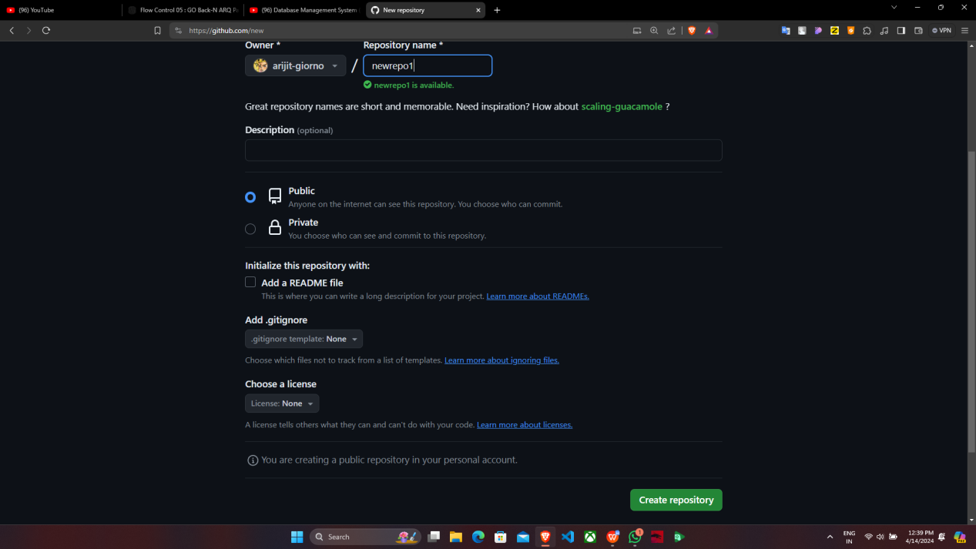

4.“newrepo1” is successfully created.

5. Go back to “Home” and click on “Settings”

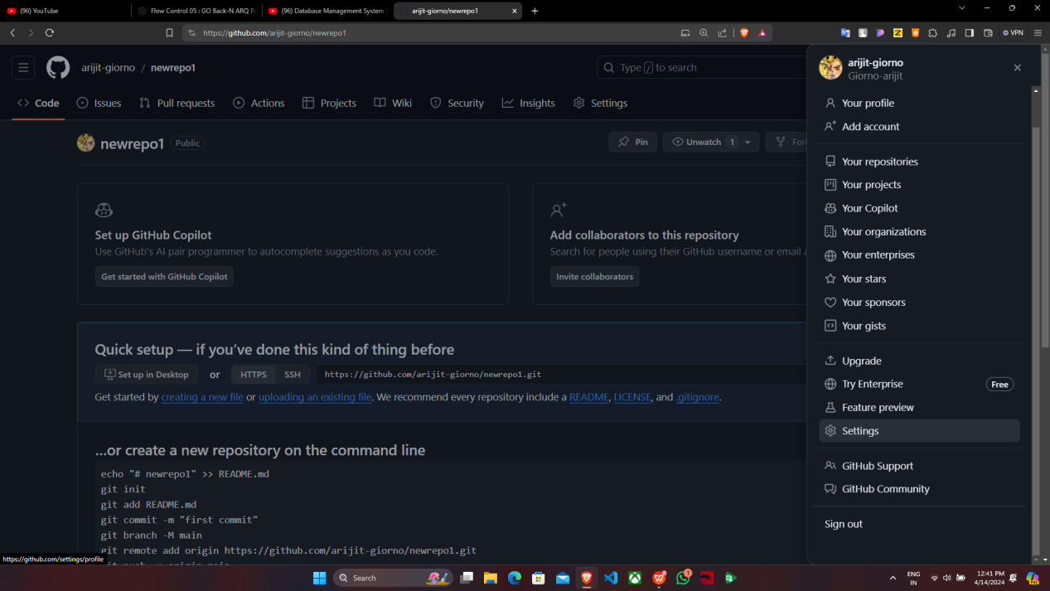

1. Under “Settings”, select “Developer settings”.

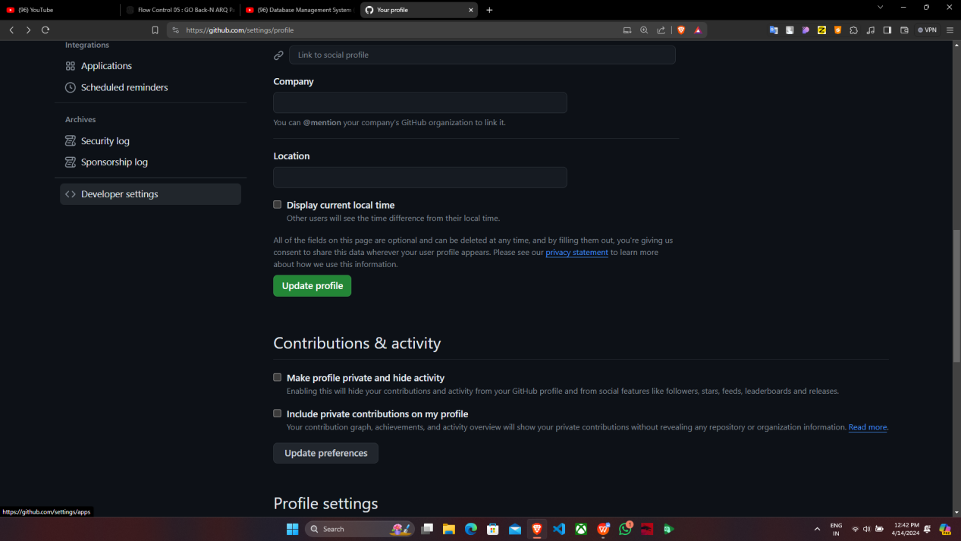

7. After clicking on “Developer settings”, under “Personal access tokens” click on

“Tokens(classic)”.

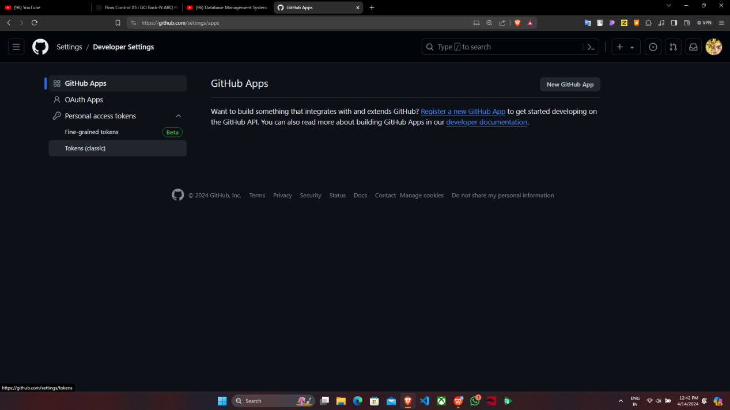8.Go to “Generate new token”, click on “Generate new token(classic)”.

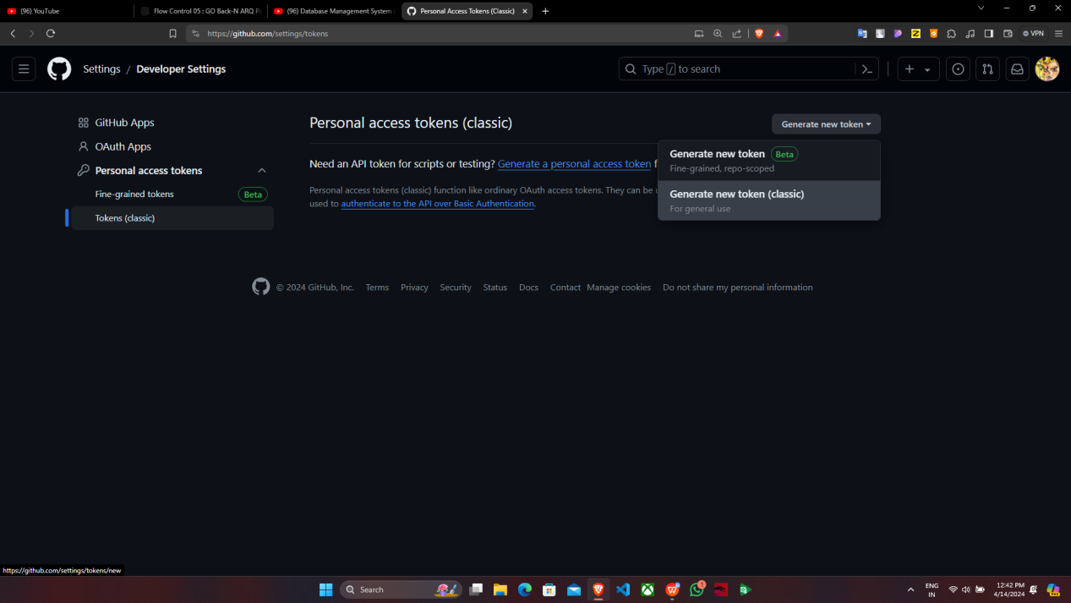

9. Under “New personal access token(classic)”, give the token name, set the

expiration to 90 days and click on all the checkboxes. Then click “Generate

token”.

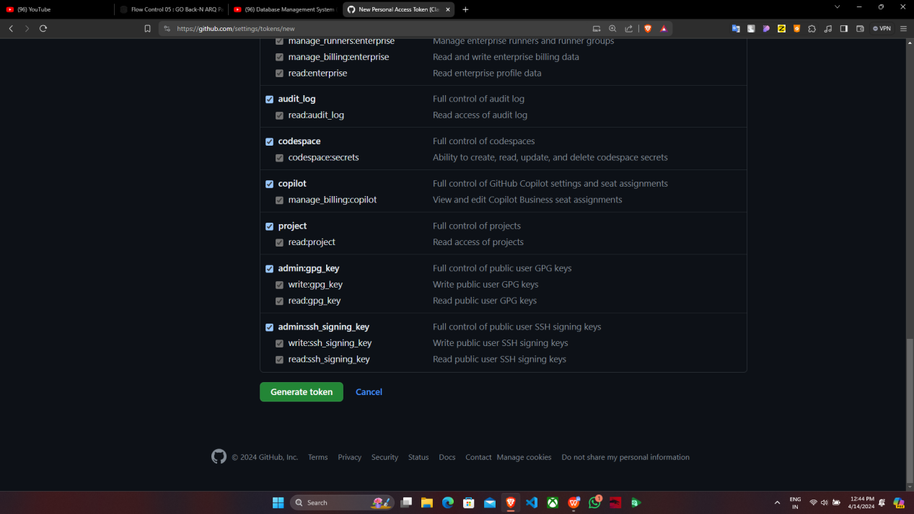

1. Token is generated successfully. Copy the token in notepad.

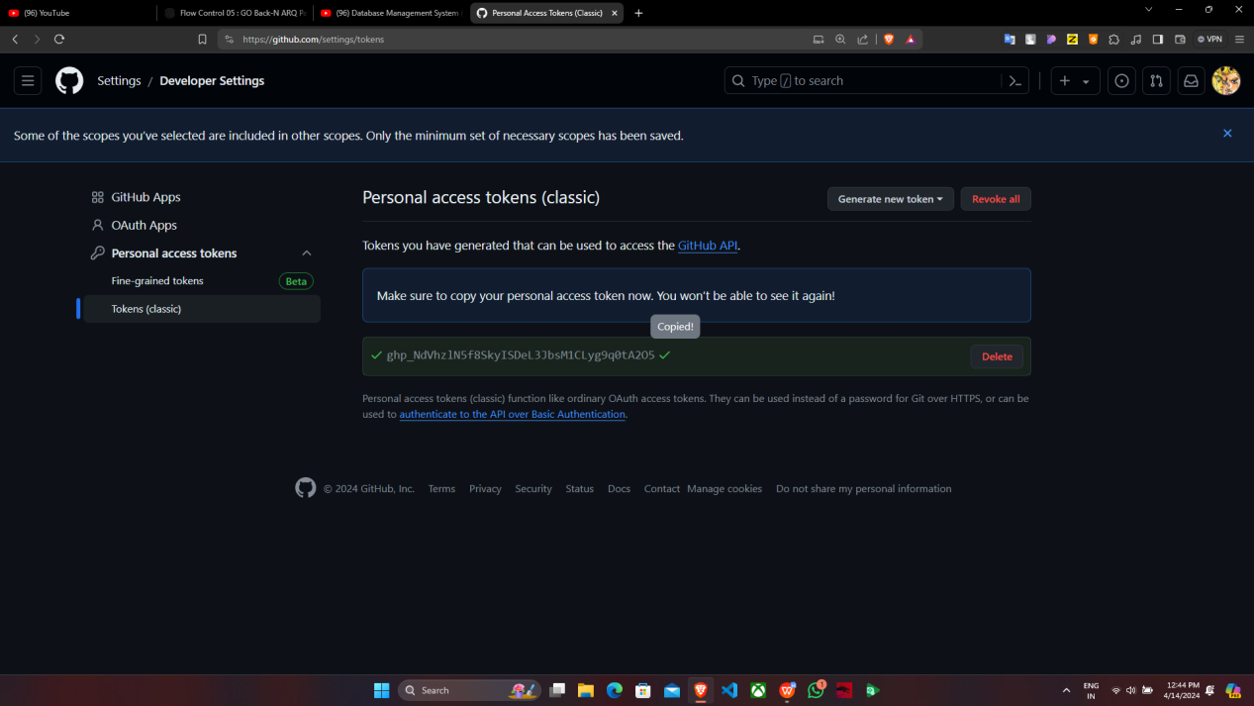

11.Now create a new folder in your desktop then right click on it and go to “Show

more options” then select “Git Bash Here”.



12.Type the following codes: After this command one window appears, go to “Token” then enter the token and click on “Sign in”.

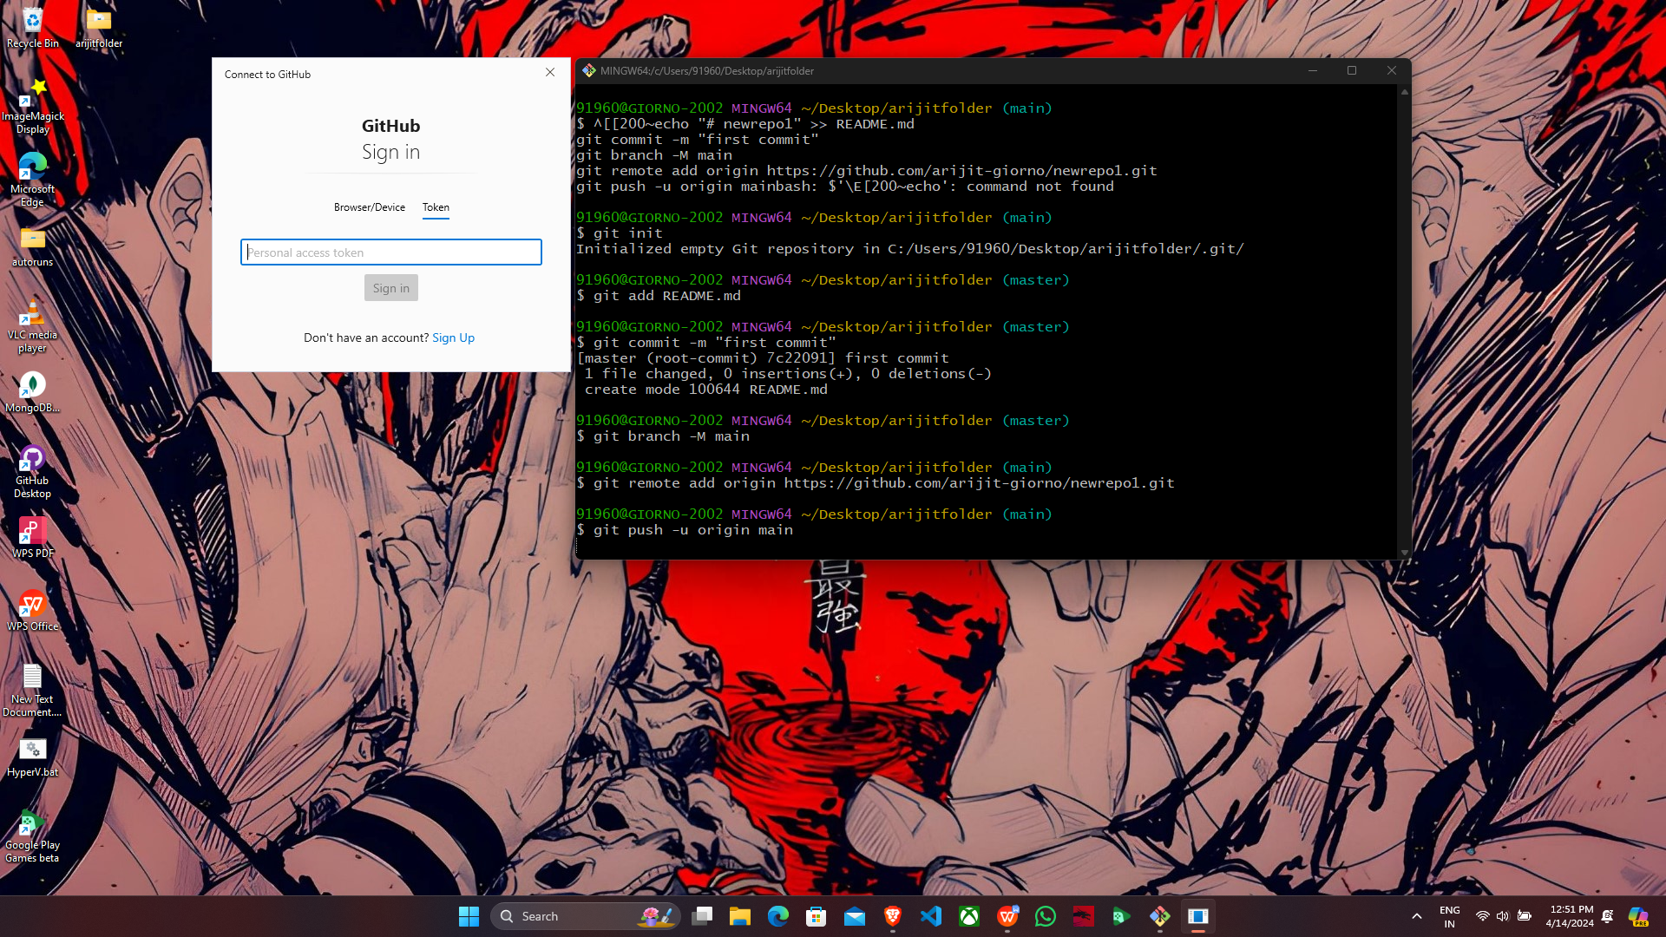

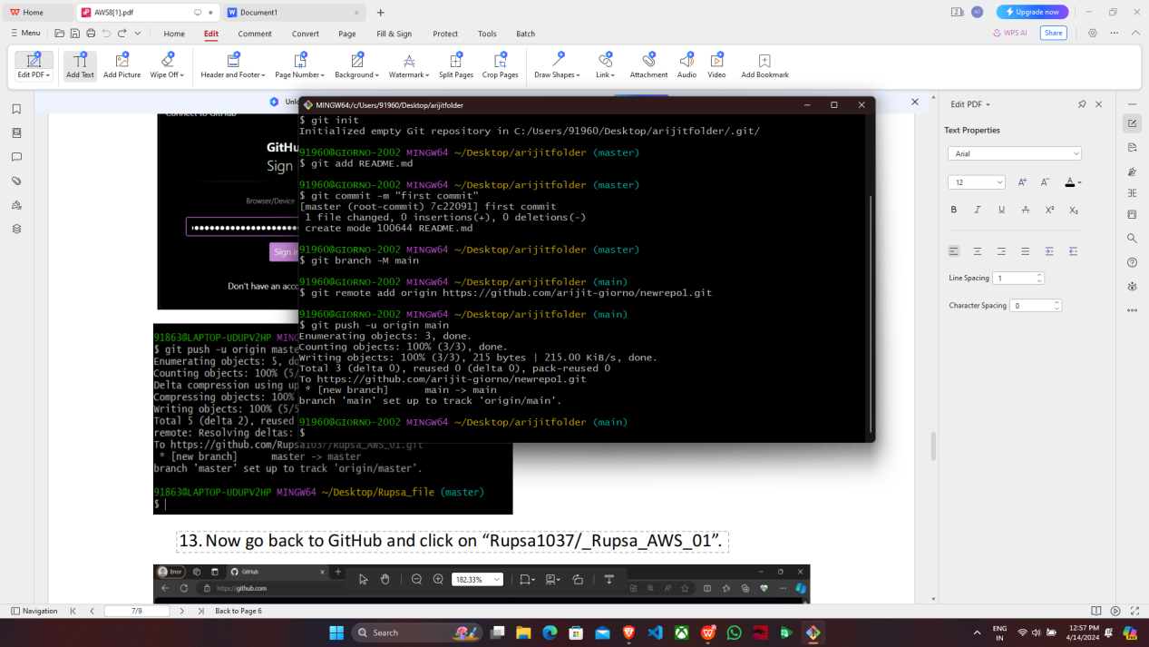

13.Now go back to GitHub and click on “mainakcris7/rewrepo1”. Here we can see that all the files are uploaded here.

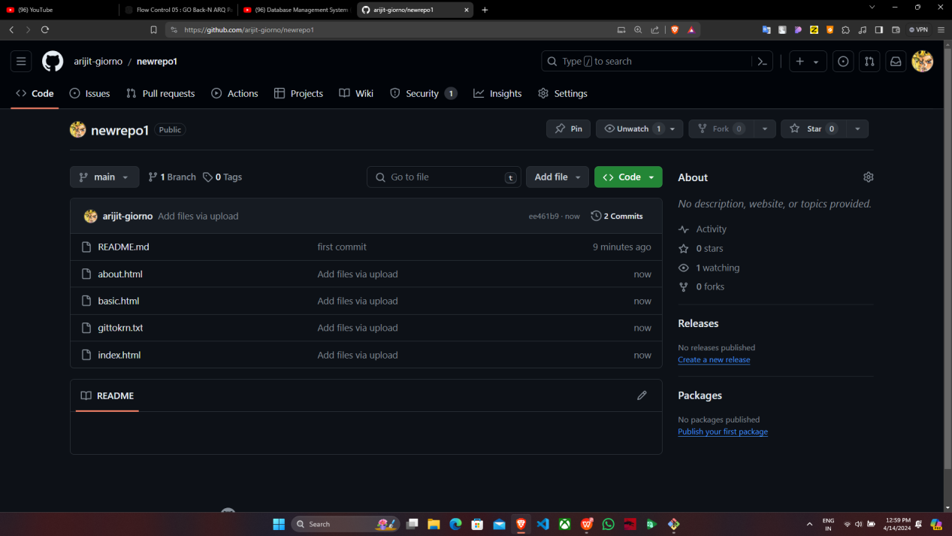

For deploying the project from GitHub to local machine, the steps are as follows:-

1. We have to create a new folder on our desktop and then right-click on the folder

then go to “Select more options” and select "Open with Git Bash".

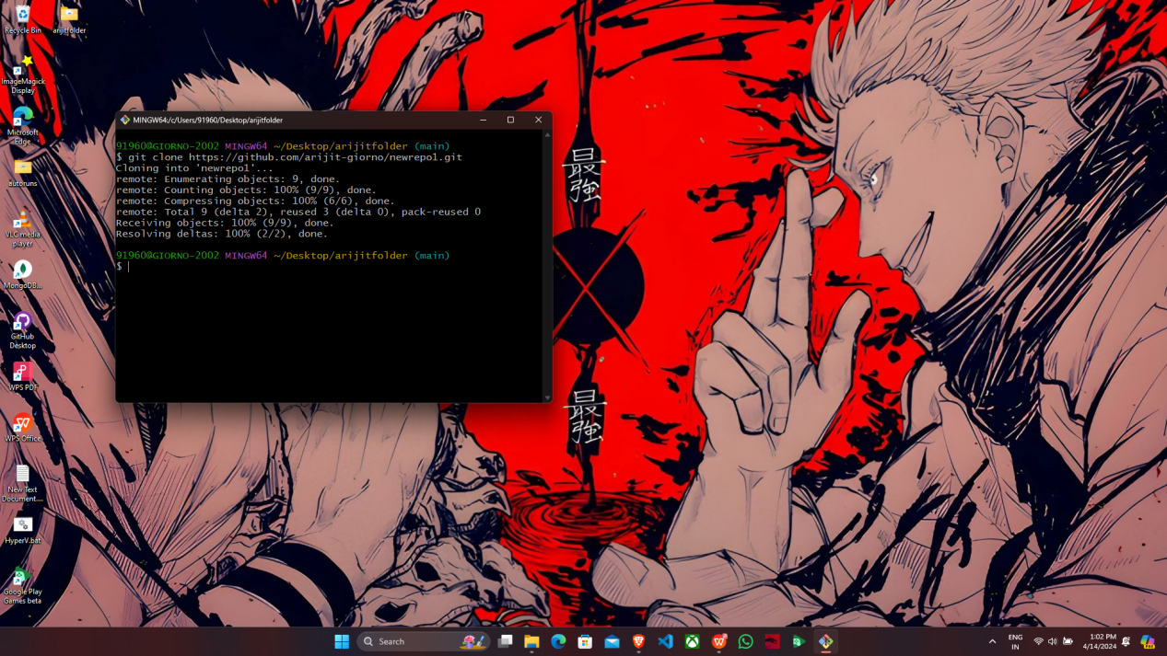

2.In the terminal we have to enter the following commands:

**git clone https://github.com/mainakcris7/newrepo1.git**

1. The files have been successfully cloned. Hence, the deployment of the project from GitHub to the local machine has been completed.

